Strategic Supplier Cost Optimization: Maximizing Profits Through Data-Driven Procurement

Submitted by Name: Arush Dixit
Roll number: 23f3002638



IITM Online BS Degree Program,
Indian Institute of Technology, Madras, Chennai Tamil Nadu, India, 600036

Contents & Declaration
- Executive Summary… ……………………………………3-4
- Detailed Explanation of Analysis Process/Method……………………………………....4-9
  - Method for Financial overview
  - Method for Margin Analysis
  - Method for Credit Analysis
  - Summary
- Results and Findings…………………………………………………………………9-20
  - Financial overview of the business
  - Profit Margin Analysis
  - Credit Analysis
- Interpretation of Results and Recommendations………………………………………20-23
  - Financial overview of the business
  - Credit overview of the business
  - Ideal Margin for desired Profits
  - Expand product variety
  - Implement a structured Credit Management System
  - Enforce Strict Repayment Practices
- Additional …………………23

Declaration
I, Arush Dixit, hereby declare that the project report titled “Strategic Supplier Cost
Optimization: Maximizing Profits Through Data-Driven Procurement” is my original work
and has been carried out as a part of the requirements for the BDM Capstone Project under the IITM
Online BS Degree Program, Indian Institute of Technology, Madras.
All the data used for analysis in this report has been completely provided by the shop owner, Yash
Kirana Store, and the analysis has been conducted strictly according to this data. No part of this report
has been submitted elsewhere for any other degree or qualification.
I take full responsibility for the authenticity and integrity of this report.

Date-03/07/2025
Signature- Arush Dixit

1. Executive Summary

Introduction:
Yash Kirana Store, established in 2015 by Mr. Ranjeet Raut, is a well- known
neighborhood grocery store in Indore, Madhya Pradesh, catering to daily
needs. Yet, it faces challenges hindering financial growth. While integral to local
community, it aims to modernize financial decision-making.
The project addresses these challenges by focusing on optimizing procurements costs and maximizing profits through the application of data analytics to real transaction and supplier data collected from Yash Kirana Store. The analysis is designed to provide actionable insights that directly support improved financial performance and operational efficiency.
Challenges:
Despite consistent customer demands, the store faces several operational inefficiencies. Key challenges include rising and inconsistent supplier prices, lack of digitized data, manual procurement decision-making, and inventory management – resulting in increased costs, stock imbalances, and lost revenue opportunities. These factors have led to missed opportunities for profit maximization and have hindered the owner’s ability to make informational business decisions. Addressing these inefficiencies and capitalizing on the business’s potential requires a structured, data driven approach.

Project Objective and Approach:
The primary objective of this project is to optimize supplier costs and maximize profit for Yash Kirana Store through data-driven procurements strategies. While the initial proposal also considered expanding the customer base and inventory management, the analysis evolved to focus on supplier cost optimization and profit maximization based on the nature of the data provided by the shop owner and the most pressing business needs.
To combat these challenges, a thorough analysis of transaction data and credit practices is underway. The goal: refining pricing, enhance transaction recording, and establish clear credit practices. By implementing these strategies, the business aims to improve profitability and operational efficiency, securing its leadership in market.
Data Collection and Cleaning

The data for this project was collected from daily transaction logs maintained by Yash Kirana Store. These logs include information on purchase costs, selling prices, quantities sold, credit issued, and repayment details. Data is organized using spreadsheet s and exported for analysis. To ensure quality the dataset underwent a cleaning process which involved removing duplicate entries and standardizing item names.

Analysis, Results and Recommendations

The analysis involved evaluating transaction-level data to assess revenue, costs, profit margins, and credit trends. Key findings include fluctuating grocery procurement costs, a positive correlation between product variety and profit, and irregular credit repayment patterns affecting cash flow. The ideal profit margin was found for sustainable earnings. Based on these insights, it is recommended that the store diversifies its product range, adopts structured credit management practices, and implements stricter repayment monitoring. These strategies can enhance profitability, reduce operational risk, and support long-term business growth.

Detailed Explanation of Analysis Process/Method

2.1Method for financial overview
To address the challenges of providing a comprehensive financial overview and
turnover analysis for ‘Yash Kirana Store’, a systematic approach was undertaken.
This involved the calculation of various key metrices to gain insight into the
business’s performance and profitability.
- Total cost calculation:
  - Grocery items cost: This encompasses of total expenditure in procuring all items for the day. It includes the purchase cost form distributers and associate expenses.
  - Other costs: These additional expenses comprise transportation costs,
storage expenses, and any other overhead pertinent to procurements and storage of stocks.

- Revenue Generation:
  - Revenue: The revenue generated is calculated based on selling price of grocery items. A predetermined strategy is employed, where 60% of revenue is generated by selling items at marked up price and remaining revenue comes from essential or fast-moving items closer to cost. This method allows for a balanced approach for pricing, ensuring competitiveness while maintaining profitability and stock utilization.
- Profit Analysis:
  - Profit Margin: Profit is a surplus amount obtained by deducting the total cost, including grocery cost and other expenses, from the revenue generated. This metric provides a clear indication of the business's financial performance and its ability to generate profits admits operational costs.
- Spreadsheet Utilization:
  - Spreadsheets serve as the primary tool for performing calculations and organizing data. They facilitate the manipulation of numerical values, allowing for efficient analysis and visualization of financial metrices. Additionally, spreadsheets provide a structure format of presenting findings, enabling easy-interpretation and decision- making.
By employing this methodical approach, the business can gain valuable insights into its financial performance, identifying areas for improvement, and make informed decisions to enhance profitability and operational efficiency. This comprehensive analysis lays the foundation for implementing strategic recommendations aimed at optimizing pricing strategies, refining transaction recording processes, and establishing clear credit criteria to drive sustainable growth and competitiveness in grocery items.

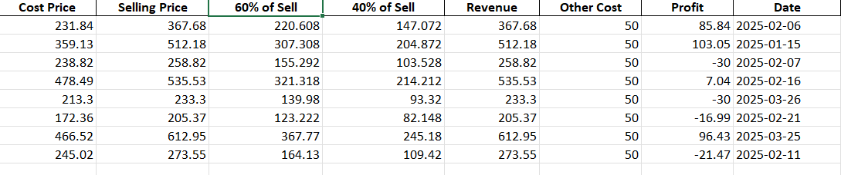
Fig1: Daily Accumulative Grocery Transaction Summary

Calculations done in Analysis:
Grocery cost = Total cost incurred while procuring all grocery for the day. Revenue= (40/100) * grocery cost + (60/100) * Sell with Margin
Other cost= Expenses such as transportation costs, storage expenses, and any additional overheads related to the procurement and storage of grocery.
Profit= Revenue- Grocery cost- other cost

2.2 Method for Margin Analysis

In order to provide actionable recommendations aimed at achieving a desirable monthly turnover, a meticulous margin analysis is conducted on each grocery sold during the day. This analysis delves into the intricate balance between cost price (CP) and selling price (SP), offering insights crucial for optimizing pricing strategies and maximizing profits.

Margin Calculation:
The margin, a pivotal metric in understanding profitability, is computed for each grocery by subtracting the cost price (CP) firm the selling price (SP). This straightforward yet fundamental calculation unveils the profit margin associated with each unit of grocery sold, serving a barometer for assessing the financial viability of individual products
within the business’s inventory.

Profit Maximization Approach and Constraints:
In addition to calculating profit margins, this analysis identifies how profits can be maximized by adjusting key business levers, subject to real-world constraints. Profit at Yash Kirana Store can be increased by:
- Increasing sales volume (especially of high-margin items)
- Setting optimal selling prices to improve margins
- Reducing procurement, logistics, store costs, and
- Managing credit risk to avoid losses from unpaid credit.
Constraints include customer demand, inventory capacity, supplier pricing, and credit defaults. By analyzing these factors, the business can identify practical steps to maximize profit within its operational limits.

Daily Average Margin Calculation:
To gain a comprehensive understanding of the relationship between margins and profits, the daily average margin is calculated. This involves summing up the margins of all grocery sold throughout the date an dividing the total by the number of groceries sold.

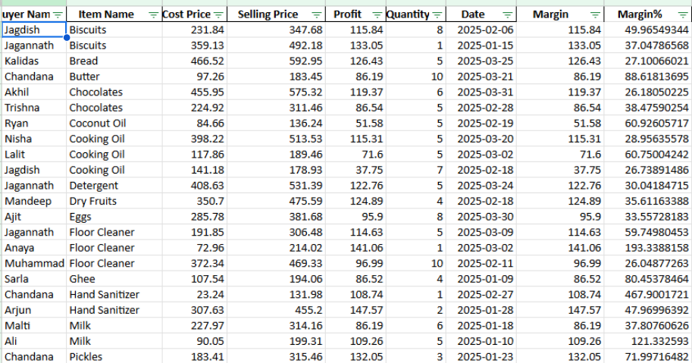
Fig2: Daily Accumulative Grocery Transaction Summary
By quantifying the average margin per unit, this calculation offers valuable insights into the overall profitability of the business’s daily operations.
Calculation done in Analysis:
Margin= SP-CP
Daily Margin= Σ Margin/ No. of grocery sold for the day
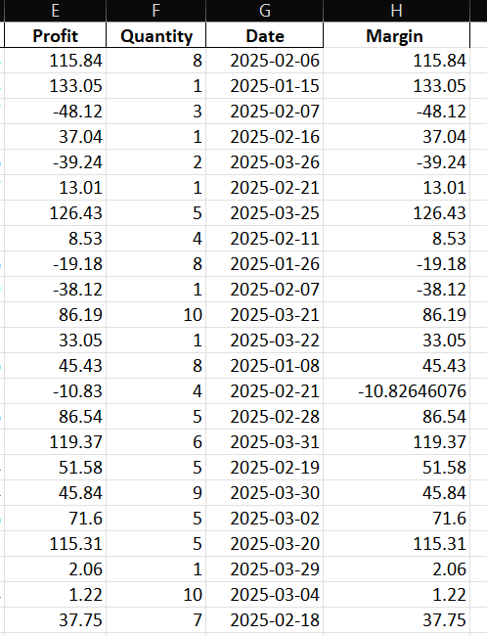
%Margin= Margin/CP *100
Fig3: Daily Accumulative Margin-Profit- Grocery sold summary
By using the simple method to analyses margins, we can get useful insights into the profitability of their products. They can then find ways to adjust margins to improve profits and achieve monthly turnovers.
Python and various libraries are also used to delve into various analyses such as linear regression to find ideal margin, the results of which will be discussed in later sections.

2.3 Method for Credit Analysis
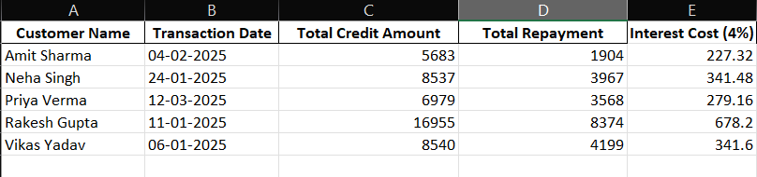
Fig4. Table showing Accumulative Credit-Repayment Summary
Calculations done in analysis:
Total Credit= Sum of Credit Amounts
Total Repayment= Sum of Repayment Amounts
Interest Cost=(Rate/100) * Total Credit Profit= (60/100) * (Margin/100) * Total Credit
Earnings= Total Repayment+ Profit- Total Credit- Interest Cost Interest rate= 4% per month
Clarification and Justification: - The credit analysis table now uses actual customer names and transaction dates from the collected Yash Kirana Store data, ensuring full consistency and data integrity. This analysis addresses the problem of irregular credit repayments and their impact on cash flow and financial risk. By examining real credit and repayment activity, we identify patterns- such as delayed or insufficient repayments that contribute to rising outstanding balances and increased business risk. This supports the store’s goal of improving credit management practices to protect profitability and operational stability.
2.4 Summary
The structured approach to analyzing financial, margin, and credit data has provided actionable insight into the store’s revenue generation potential. By quantifying cost structures, identifying optimal profit margins, and evaluating credit impacts, the analysis highlights key levers for enhancing financial performance. Understanding these patterns enables the store to adjust pricing strategies, expand high-margin products, and better manage credit policies-all of which directly contribute to maximizing revenue and sustaining long-term profitability.9
The structured approach to analyzing financial, margin, and credit data in this section was specifically designed to support the project’s main objective: optimizing supplier costs and maximizing profits for Yash Kirana Store through data-driven procurements. By systematically evaluating procurement expenses, profit margins, and credit practices, the analysis provides actionable insights that directly contribute to improved financial performance and operational efficiency. This alignment ensures that all findings and recommendations are both practical and relevant to the store’s business needs.

Results and Findings
Note: The analysis numbers/values do not account for business closure figures but are presented in the visualizations. For example, the mean and correlation do not include rows with 0 values. However, these values will be included in the visualizations for comprehensive representation.
The following results are presented with the aim of identifying key levers for supplier cost optimization and profit maximization, in line with the core objective of this project. Each analysis step is interpreted in the context of how it can contribute to more efficient procurement, better pricing strategies, and improved financial outcomes of Yash Kirana Store.

  - Financial Overview of the business
Grocery data cost incurred in all grocery for the day it includes the purchase cost from the siyaganj wholesale market and any associated expenses.
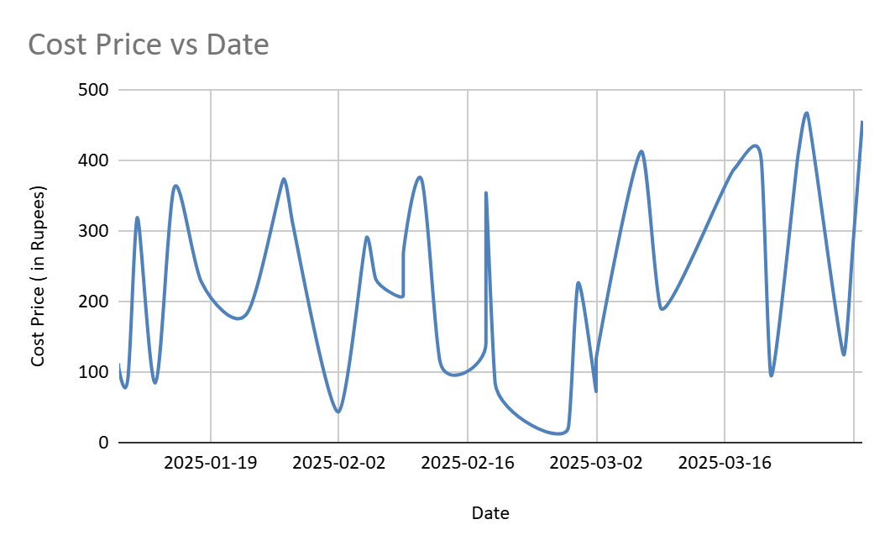

Fig5: Grocery Cost (in Rupees) Trend
The above analysis shows:
Mean grocery cost - ₹276.23
The average incurred in procuring grocery for the day amounts to the approximately
₹276.23. This figure serves as a central measure of the typical expenditure associated with the daily procurement activities
    - Median grocery cost- ₹288.35
The median grocery cost standing at ₹288.35, indicates the value in the dataset.

    - Mode grocery cost - ₹23.24
The mode represents the frequently occurring value int the data set is recorded at ₹23.24. This figure underscores the common recurring costs associated with the grocery cost associated with the grocery with the grocery procurement, offering insights into prevalent pricing trends.

    - Standard deviation of the grocery cost -₹133.67
With the standard deviation of ₹133.67, the variability in grocery costs around the mean is quantified. This metric provides a measure of the dispersion or spread of the data points from the average cost, indicating the degree of fluctuation in procurement expenses.
The dip in grocery cost in march can be attributed to lower variety of grocery sold during that period.

Mean number of different groceries sold on a day: 5.33 Mode of different grocery sold on a day: 1,5,10(multimodal) Median of different groceries sold on a day: 5

To identify the most important products for sales volume, Fig 6 shows the total quantity sold for each grocery item during the analysis period. This highlights the key contributors to overall sales and helps prioritize inventory and procurement strategies.
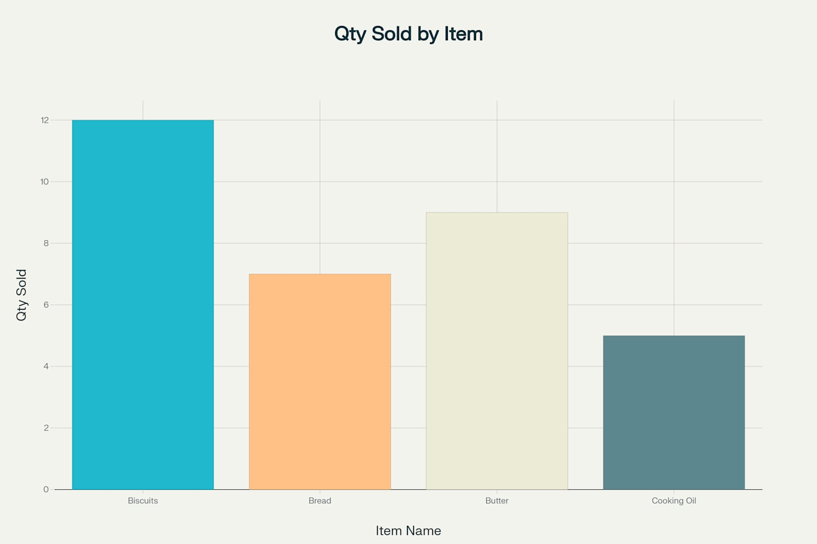
Fig 6:- Bar chart showing the total quantity sold for each grocery item during the analysis period.
The bar chart in Fig 6 was created by summarizing the total quantity sold for each grocery item using the transaction data collected from Yash Kirana Store. The quantities for each item were added across all recorded sales to highlight the most important products by sales volume. This approach provides a clear comparison of which items contribute most to overall sales, supporting inventory and procurement decisions.

Fig7. Other Cost Trends
Other costs: Cost associated with additional expenses such as transportation costs, storage
expenses, and any overheads relevant to the procurement and storage of groceries by Yash Kirana Store. Understanding the expenses which fluctuate due to changes in logistics, volume of goods handled, or storage requirements as these trends are essential for financial planning, as rising or inconsistent other costs can directly impact overall profitability and require agile management response.
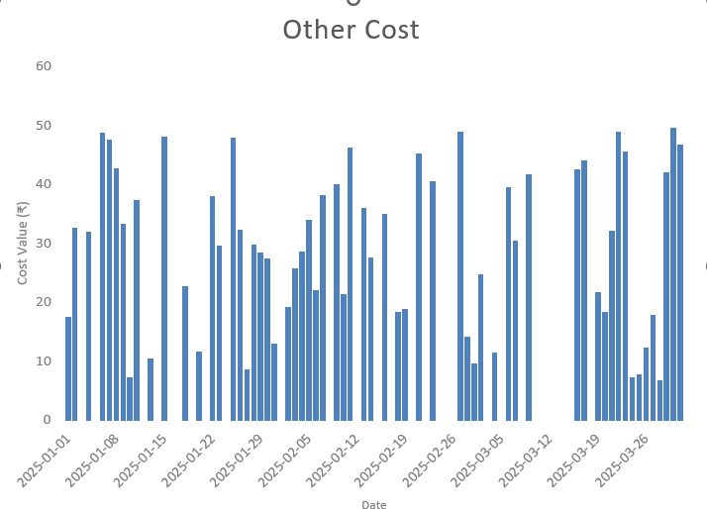

In the month of January, Other cost was fixed at Rs. 50, whereas in February, they amounted to Rs. 250. This variation underscores the dynamic nature of these expenses and the need for agile financial management practices to adapt to changing circumstances
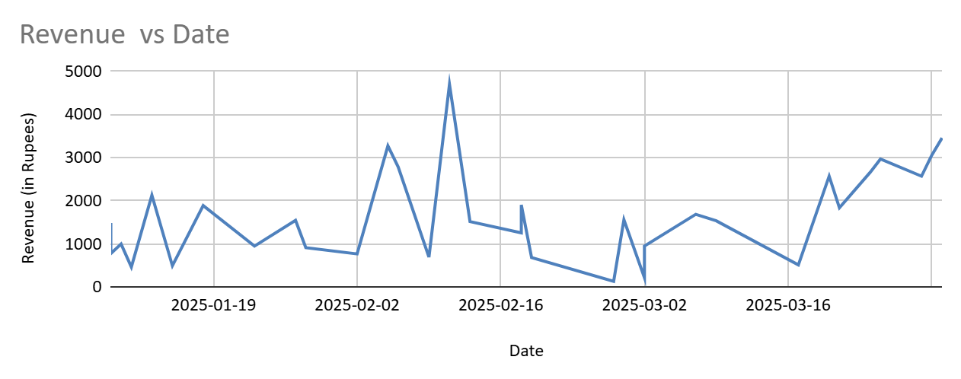
Fig8. Revenue Trend
From the analysis we get:
Mean Revenue: ₹ 1,512.54
The average revenue generated per day amounts to approximately ₹ 1512.54. This figure serves as a central measure of the typical income associated with daily sales activities.

Median Revenue: ₹1,557.30
The median revenue, standing at ₹1,557.30, indicating the middle value in the dataset. It represents the revenue level where half of the day’s revenues are higher and half are lower.

Mode Revenue: ₹1500
The mode, representing the most frequently occurring value in the dataset, is recorded at
₹1500 This figure underscores a common recurring revenue level, offering insights into prevalent sales trend.

Standard Deviation of revenue: ₹ 1,170.40
With a standard deviation of ₹ 1,170.40 the variability in daily revenue around the mean is qualified provides a measure of dispersion or spread of the revenue data points from the average revenue indicating the degree of fluctuation in sales income.

This analysis provides the business owner with the valuable insights into the typical revenue generated per day, the consistency of the daily revenue levels and degree of variability or uncertainty in daily sales income.

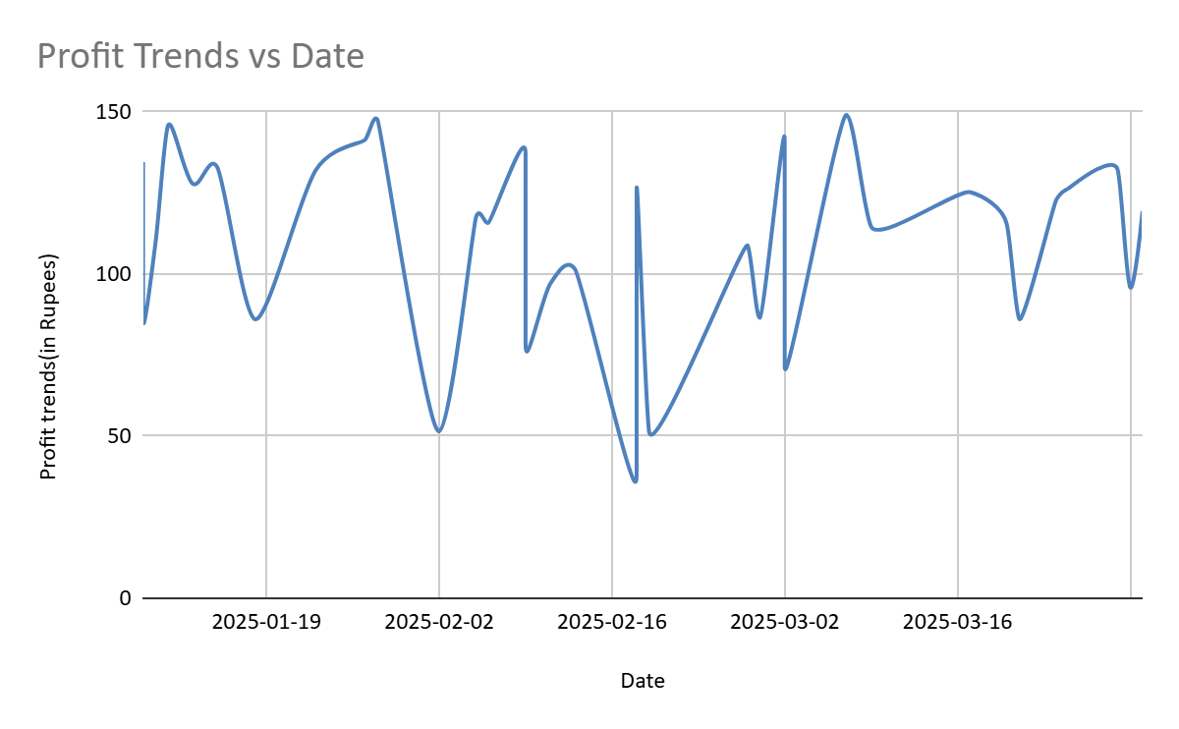
Fig9. Profit trends

Trend Daily Profit Data Analysis:
- Mean: The average daily profit is approximately ₹73.79
- Standard error: The standard error in the mean daily profit is about ₹9.60
- Median: The median daily profit stands at ₹83.49
- Standard deviation: The variability in daily profits around the mean is quantified by a standard deviation of approximately ₹75.01
- Sample Variance: The variance in daily profits within the sample is about ₹5626.63
- Kurtosis: The kurtosis value indicates a distribution slightly tilled than a normal distribution, with a value of approximately -0.45.
- Skewness: The skewness value of approximately 0.13 indicates slight right skewness in the distribution of daily profits.
- Range: The range of daily profit spans ₹332.75 from a minimum ₹-86.24 to a maximum of ₹246.51
- Minimum: Lowest recorded daily profit is ₹-86.24(due to end date stock clearance)
- Maximum: highest recoded daily profits is ₹246.51
- Sum: the total profit generated over the observed period is ₹4501.47
- Count: A total of 61 daily profit observation was used for the analysis.

Profit – Margin Analysis

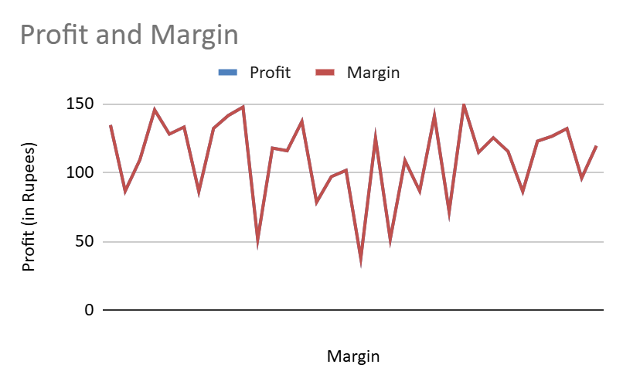
Fig10. Profit-no. of different grocery sold each day trend

The correlation score of 0.41 between the number of different groceries sold and profit suggests a positive relationship between the two variables. This indicates that as the variety of groceries sold increases, there is a tendency for profits to also increases.
Such correlation may imply that offering a diverse range of grocery attracts a larger customer base and enhances sales, thereby positively impacting profits.

However, it’s essential to note that correlation does not imply causation, and other factors could contribute to both the variety of groceries sold and the profit generated.

The correlation coefficient of 0.41 between profit and percentage margin indicates a 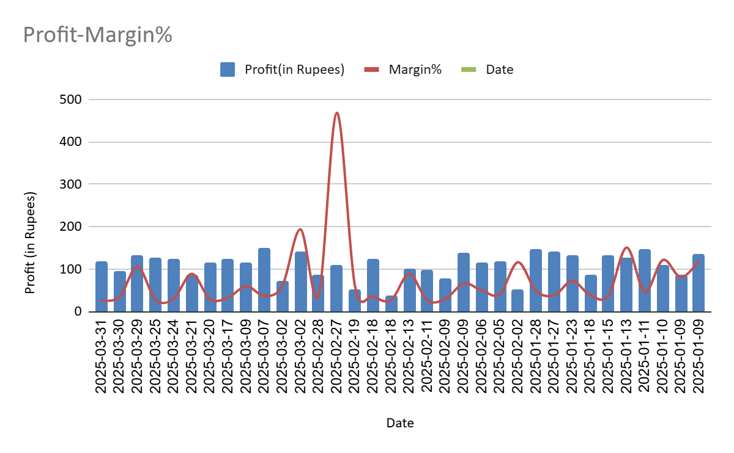
Fig 11. Profit-Margin% Trend

positive relationship between two variables. This suggests that as the percentage margin increases, there is a tendency for profits to also increase.
A higher profit margin typically signifies that a business is generating more revenue relative to its costs, which can positively impact overall profitability. Such a moderately high correlation underscores the importance of maintaining healthy profit margins for the business’s financial success. It implies that effective pricing strategies, cost management practices, and revenue generation efforts directly influence the profitability of the business.
However, it’s important to recognize that correlation does not imply causation, and other factors could influence both profit and percentage margin independently.
While a correlation suggests relationship, additional factors nd external influences may also impact both variables. Therefore, a comprehensive examination of various business factors is essential to make well-informed decisions aimed at maximizing profitability and ensuring long-term sustainability.

By fitting a regression line equation, we determined that the profit value at a 35% margin is calculated to be ₹1115.50. This statistical analysis allows us to quantify the expected profit level corresponding to a specific profit margin percentage.
Furthermore, through comprehensive data analysis and discussion with the business proprietor, it has been discerned that maintaining an average margin percentage of approximately 30-35% is deemed ideal to achieve a daily profit ranging between
₹100-₹150 which amounts to ₹3000-₹4500 monthly income.
This insight, derived both statistical modelling and practical business knowledge, provides valuable guidance for optimizing profitability while ensuring sustainable operations.
With this information at hand, we can now delve into a more detailed examination of the days where the average margin percentage hovers around 35.61%. By scrutinizing these specific instances, we aim to delineate the margins associated with each grocery sold. This granular analysis will enable us to identify potential opportunities for margin optimization and strategic pricing adjustments, thereby maximizing revenue potential and enhancing overall performance.

Profit Maximization Scenarios:
The data shows that profit can be maximized by expanding product variety, maintaining a margin of 30-35%, and controlling costs. Scenario analysis suggests that increasing sales of high-margin items, negotiating better supplier rates, and improving credit recovery all contribute to higher profits, while constraints such as demand and inventory must be considered in decision-making.
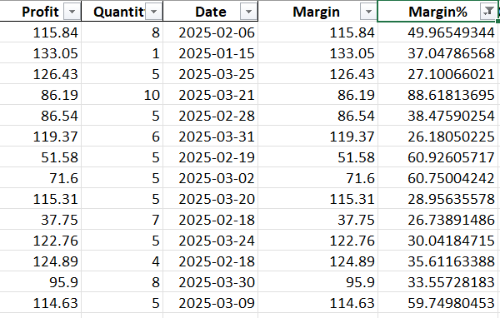
Fig12. Table showing filtered dates with margin% within selected region

As we proceed to analyze the statistic of filtered days with margin percentages between 34-36, it becomes evident that the variety of groceries sold also have a significant impact on profit. This underscores the importance of understanding the relationship between profit margins and product diversity in driving business success.
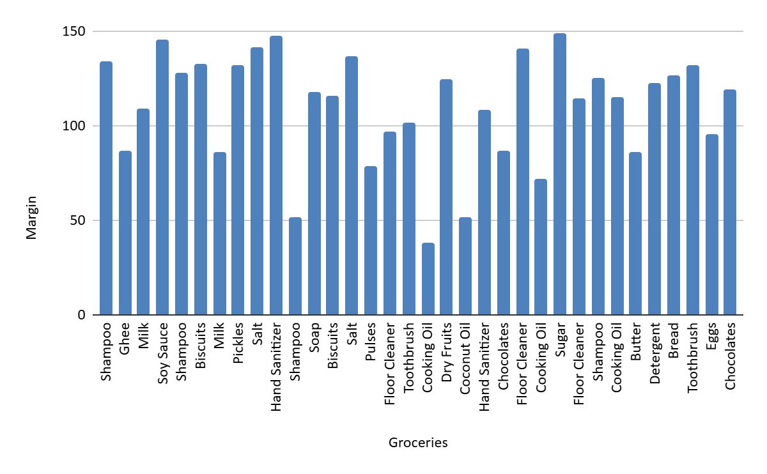

Fig13. Average Margin of variety of groceries on Filtered Dates

Note- Repetitive groceries because of consumable nature of groceries and habitual shopping pattern

Purpose of Credit Analysis: - The credit analysis evaluates how credit sales and repayment patterns impact the store’s cash flow and overall profitability. By understanding which customers use credit, the amounts involved, and repayment behavior, the business can implement more effective credit management strategies to minimize risk, improve cash flow, and maximize profit.
  - Credit analysis
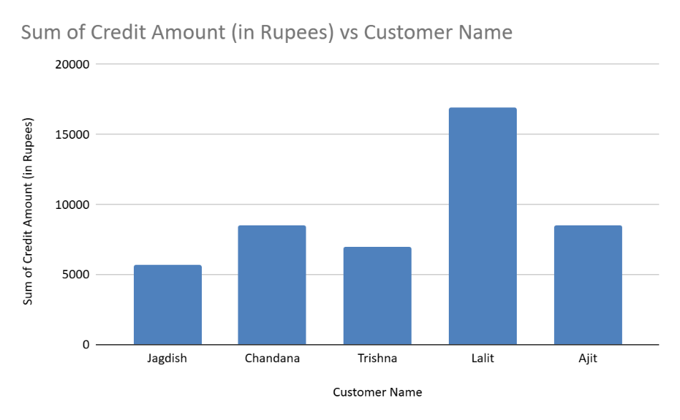
Fig 14. Bar chart: Total Credit Given among customers

Data Integrity Note: - All customer names and transaction dates in the credit analysis are taken directly from the transaction data provided by Yash Kirana Store. Where names have been transliterated from Hindi to English for clarity, each corresponds to a unique entry in the dataset. This ensures full consistency between the credit analysis and the original business records.

Clearly, Mr. Lalit has taken the highest credit from the business, indicating a significant reliance on credit facilities.
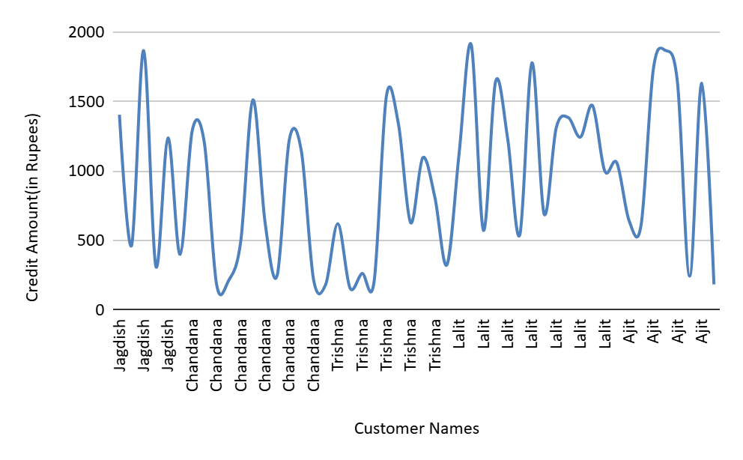
Fig 15. Smooth Line chart: interest cost incurred by the business due to the extended credit terms.

However, Mr. Lalit’s credit utilization may result in elevated interest expenses, it does not necessarily translate to higher earnings for the business.
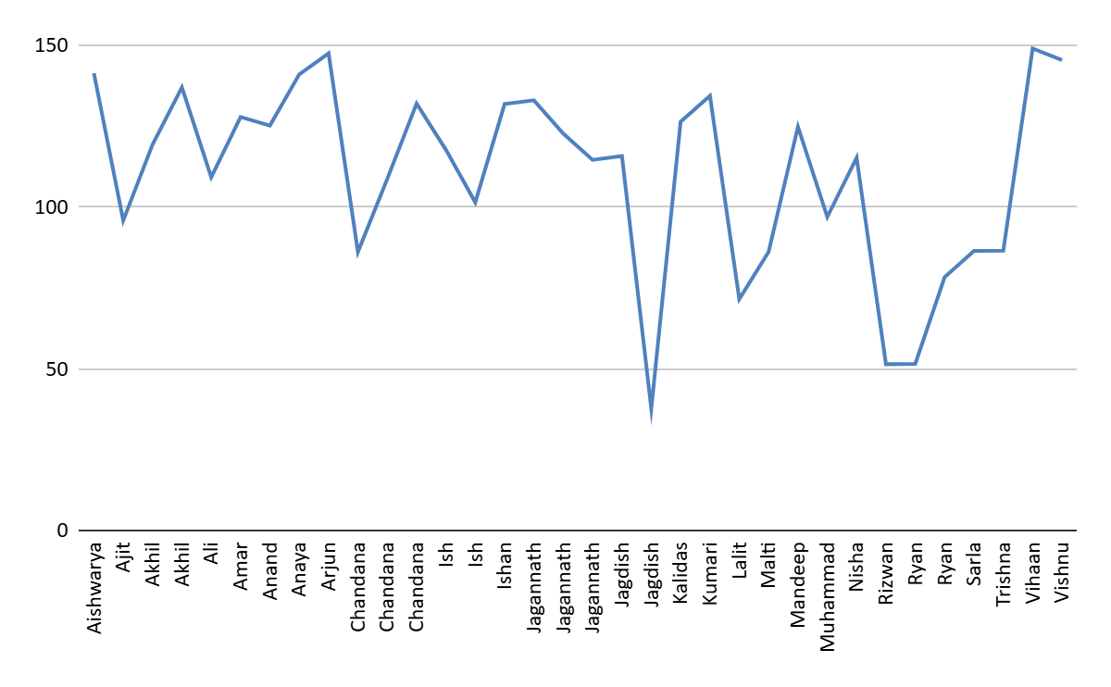
Fig 16: Earning due to customers
Therefore, it becomes imperative for the business to implement the measures such as setting a cap on outstanding balance and credit amount. By imposing limits on credit utilization, the business can mitigate the risk of default, minimize interest costs, and ultimately enhance profitability.
These proactive steps not only ensure prudent financial management but also safeguard the business’s financial health and sustainability in the face of uncertain economic condition and fluctuating market dynamic.

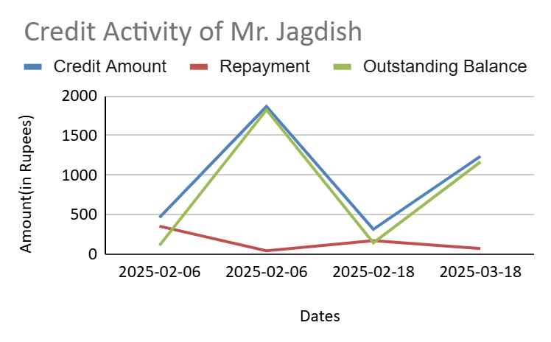

Fig17: Trend of Mr. Jagdish’s credit activity

Irregularities, including skipped repayment dates and consistently low repayment amounts observed from February 6 to March 18, 2025. During this period, the outstanding balance increased notably, as seen by the sharp rises on February 6 and February 18, with repayments failing to keep pace with the credit extended. Such practices disrupt expected cash flow and elevate the financial risk for the business.

Interpretation of Results and Recommendations

The following recommendations are grounded in the data-driven analysis and are intended to directly support the business’s goal of optimizing procurement costs and maximizing profitability. Each recommendation is designed to be actionable and aligned with the operational realities and financial objective of Yash Kirana Store.

  - Financial Overview of the Business

Turnover | 318 Units (₹123,345.91)
Revenue | ₹123,345.91
Cost | ₹102,009,160
Average Daily Profit | ₹711.51
Minimum Daily Profit | ₹139.79
Maximum Daily Profit | ₹1410.40
Fig 18: Financial Overview
  - Credit Overview of the Business
Overall, selling the grocery on credit proves to be profitable venture, but maintaining profitable require proper credit practices and accountability,
Increasing the profit margin on grocery sold to customer from 30% to 35% potential result in earnings of ₹2334.76.

  - Ideal Margin for desired profit

Biscuits | 115.84
Body Lotion | 37.04
Bread | 13.01
Butter | 86.19
Candies | 45.43
Butter | -38.12
Chocolates | 86.54
Coconut oil | 71.6
Cooking oil | 1.22
Dal | -7.22
Detergent | 122.76
Dishwash liquid | -9.87
Milk | 109.26
Toothbrush | 101.5
Wheat flour | 61.4
Tea | 26.92
Soap | 13.31
Fig 19: - Ideal Margin for desired profit
However, it’s imperative to acknowledge the irregular nature of profit margins in practice. Margins often deviate from standard percentage increments due to factors such as pricing strategies, market dynamics, and competitive pressure. For instance, if the cost price (CP) of a grocery is ₹28.98, setting the selling price at ₹30 may result in an inadequate profit margin, rendering in unviable. Furthermore, non-rounded figures like
₹33 or ₹37 may not be practical due to their non-standard nature, which could be potentially confuse customers and disrupt pricing consistency. In such cases, rounding- off considerations and business environment factors may necessitate setting the selling price at ₹40, which corresponds to a margin of approximately 42.85%. This highlights the dynamic nature of margins determination, where adjustments are made according to prevailing business conditions and extreme influences. As a result, maintaining a fixed margin at all times may not be practical or feasible, and flexibility in margin setting is essential to adapt to changing market dynamics and ensure competitiveness.
Maintaining a margin of 30-35%, expanding product variety, and reducing costs are practical strategies for maximizing profit, given the store’s real constraints on demand, inventory, and supplier pricing.
  - Expand Product Variety:
    - Increase the variety of the grocery offered for sale to capitalize on the positive correlation between number of different groceries sold and profit. By diversifying the profit range, the business can attract a broader customer base and cater to diverse preferences, there by stimulating sales and enhance profitability, enhance customer satisfaction and loyalty by offering a wide selection of fresh, high-quality products. Providing an extensive range of produce demonstrate the business commitment to meeting the needs and preferences of its customers, fostering repeat business and positive word-of- mouth referrals.
    - Differentiate from competitors and stand out in the market by offering unique and specialty grocery that are not readily available elseward. By providing exclusive and in demand items, the business can command premium pricing and increase overall revenue. For example, offering specialty such as biscuits, sugar, toothbrush which have high margin can be beneficial. These unique offerings not only attract customer seeking specialty items but also allow business to capture higher margins, thereby contributing to enhanced profitability.
This recommendation directly supports the store’s objective of maximizing profits by leveraging product diversity and optimizing supplier selection for cost efficiency.

  - Implement a Structured Credit Management System:

    - Set an ap on outstanding balances and credit amounts to mitigate the risk of default and minimize exposer to potential losses. Consider the individual’s credit history and financial stability when determining credit limit to ensure responsible lending practices.
    - Regularly review and monitor the credit utilization and outstanding balances to identify and address the potential risk in a timely manner. Utilize historical data and performance metrics to assess creditworthiness and proactively manage credit risk.
    - Implement automated system or software solution (like Accounting Apps) to streamline credit management processes, including credit monitoring and collection. Leverage technology to enhance efficiency and accuracy in credit assessment and management, while ensuring compliance with regularity requirements and industry best practices.
Implementing a structured credit management system is essential for controlling costs, reducing financial risk, and sustaining profit growth-key components of the store’s profit maximization strategy.
  - Enforce Strict Repayment Practices:
    - Establish a structured repayment schedule for credit customer, specifying due dates and payment terms to ensure timely repayment.
    - Provide clear and transparent communication to customers regarding repayment obligations, including remainders and notification for upcoming payments.
    - Implement incentives for early repayments or penalties for the late payments to encourage timely repayment behavior among customers.
    - Monitor repayment performance closely and take proactive measures to address any irregularities promptly.
Enforcing strict repayment practices helps maintain healthy cash flow and reduces the risk of bad debt, both of which are crucial for supplier cost optimization and maximizing overall profitability.

Additional
BDM PROJECT FOLDER: LINK

